SMART TRANSPORTATION SYSTEMS

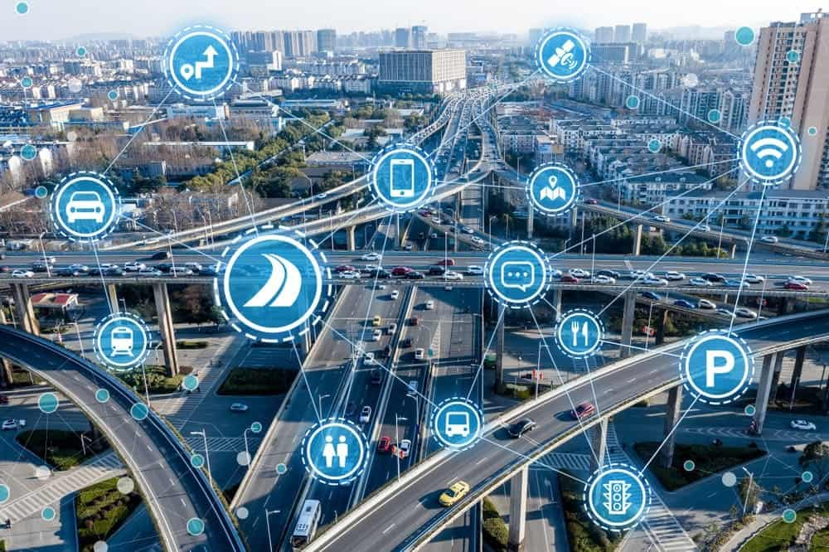

BY :

Abir Rakrak

Doha Sassa

Table of contents:

I-Introduction-----------------------------------------3

II-What is smart transportation----------------3-4

III-The main benefits of transportation technology------------------------------------------4-5

IV- Examples of Urban Transportation Technology-----------------------------------------5-6

V-General steps for developing intelligent transportation and control systems---------7-8

VI-Approaches for prediction of traffic parameters-----------------------------------------8-9

VII-Machine learning algorithms used to detect, recognize and track traffic-related objects------------------------------------------------10

VII-Traffic prediction using GRU------------11-17

**I-Introduction:**

smart transportation and smart city traffic management are revolutionizing how cities approach mobility and emergency response while reducing congestion on city streets. How? With sensors, advanced communication technologies, automation, and high-speed networks.

The art and science of moving from one place to another is an inherent part of our lives — not just today but throughout history. From chariots and horses to carriages, automobiles, steam trains, and spacecraft — being on the move is a part of being human.

Civilization has come a long way from riding horses and camels to get from place to place. With the emergence of intelligent transportation systems and the Internet of Things (IoT), the world is entering the next stage of movement — smart transportation. If the term sounds vague or triggers mental images of autonomous flying cars and hamster-like, high-speed tubes, don’t worry.

This project will lay out what exactly smart transportation is, how it works, and many of the benefits it brings along with some real world examples in use today. And we'll also cover the different types of intelligent transportation systems being deployed today.

**II-What is smart transportation:**

According to the US Department of Transportation, “Intelligent Transportation Systems (ITS) apply a variety of technologies to monitor, evaluate, and manage transportation systems to enhance efficiency and safety.” Putting visions of science fiction-style transportation aside for the moment, this definition can be simplified into the following concepts for what makes up smart transportation: management, efficiency, and safety. In other words, smart transportation uses new and emerging technologies to make moving around a city more convenient, more cost-effective for both the city and the individual), and safer.

What emerging technologies are facilitating these new opportunities? Primarily the proliferation of IoT devices and 5G communication technology. The former provides for inexpensive sensors and controllers that can be embeddedd into nearly any physical machine to be controlled and managed remotely. The latter provides the high-speed communications needed for managing and controlling transportation systems in real time with minimal latency.

Smart transportation is not just a theory for the future; it is being implemented today in several cities with their successes and failures being used to improve systems in new locations. Some of the cities that are implementing new transportation technologies may surprise you at first. Of course, global hubs like New York City have embraced smart transportation for their ever increasingly intelligent city. However, the rural state of Wyoming is also a leading testbed for connected vehicles. This is because the cowboy state is a major freight corridor — autonomous transportation of goods across the country can drastically improve supply chain efficiency and reduce the need for long-haul drivers forced to balance tight timelines with their human need for rest.

**III-The Main Benefits of Transportation Technology:**

The benefits of smart technology and the advantages they bring to transportation within a smart city are numerous.

Smart Transportation is safer: By combining machine learning with IoT and 5G, autonomous transportation systems (both in vehicles and in stationary infrastructure such as intersections) have proven to reduce the “human factor” in accidents. Computers don’t get distracted or fatigued or emotional.

Smart Transportation is better managed: Data collection is an important key to responsible public management of infrastructure. Smart transportation not only provides detailed data points for every aspect of the transportation system, but allows administrators to better monitor operations, track maintenance needs, and identify key sources of problems that need to be fixed.

Smart Transportation is more efficient: With better management comes more efficient use. Quality data can help to pinpoint areas where efficiency can be improved. Maybe a slight adjustment in train schedules would provide for better fill rates, Or, perhaps bus routes would better serve the community if stops were allocated differently.

Smart Transportation is cost effective: Because smart transportation makes better use of the resources available, it can cut down costs thanks to preventative maintenance, lower energy consumption, and fewer resources used towards accidents. Cost savings can also be gained by riders when inexpensive public transit is efficient enough to compete with private vehicle ownership.

Smart Transportation provides rapid insights: City traffic management centers (TMCs) can get rapid visibility and notifications for trouble spots or city-wide issues affecting congestion on city streets, public safety, and emergency response systems, in order to take action or communicate more effectively with other agencies and emergency responders.

## IV-Examples of Urban Transportation Technology :

## Miami Dade Advanced Traffic Management System:

## The county of Miami Dade is the most populated county in Florida, with a population of over 2.5 million residents. Managing the flow of traffic across urban area that makes up the city of Miami and its surrounding areas, including the operation of over 2,700 signalized intersections, is the responsibility of the County of Miami Dade. In fact, the number of signalized intersections and mid-block crossings, is increasing by dozens every year, according to their Traffic Management website.

## The Miami Dade Advanced Traffic Management System (ATMS), which includes Digi 4G LTE cellular routers as part of the communications infrastructure in county-wide traffic cabinets, is designed to reduce congestion and delays and improve mobility, county-wide.

## SEPTA PTC

## SEPTA (Southeastern Pennsylvania Transportation Authority) manages the light rail, subway, and bus services for Philadelphia. With over one million riders daily, these services need to be reliable and safe each and every time a vehicle departs. This is why SEPTA built a positive train control system (PTC) to signal trains, prevent derailments and crashes, and monitor speed and signal violations.

## SEPTA accomplishes this with the Digi WR44-RR mobile access router. When integrated onto a train, this device allows for remote communications with wayside sensors over a radio link. The device sends signals with train movement data while receiving information regarding closures and other factors that would necessitate a change in plan. This keeps trains from chugging forward into a dangerous situation.

## SMART Dispatch System

## Public transport in smart cities is a key area for advancement in connected technologies. In Detroit, SMART (Suburban Mobility Authority for Rapid Transit Authority) manages and dispatches over 300 buses across the city. As an integral part of how the population gets around, it is important for these buses to be on time, safe, and breakdown free. To manage the dispatch and location tracking of buses, the city used an analog radio network with three radio towers scattered around the city.

## When it was time for an upgrade, they utilized the Digi WR44 R mobile cellular router. This switch from analog to digital allowed for significantly better management and tracking. The new technology allowed SMART to not only see each vehicle’s location, but also view their speed and monitor maintenance data for each bus. This allowed for better dispatching if a bus started to run behind schedule as well as preventative maintenance to mitigate breakdowns and major repairs, saving them an estimated $70,000 per year.

**V-GENERAL STEPS FOR DEVELOPING INTELLIGENT TRANSPORTATION AND CONTROL SYSTEMS:**

The following figure shows the general steps of developing intelligent transportation systems :

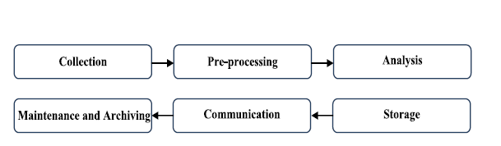

**1. Collection:** Traffic data are collected using different methods, such as: A. Image- or video-based methods. Surveillance cameras are used to visually observe road traffic in a specific area and record or stream the captured images/videos to control rooms. It is widely used in the area of managing road traffic due to efficiency and ease of maintenance. However, video and image contents require lot of storage, network bandwidth, and computation complexity. B. Sensor-based methods, such as ultrasonic sensors, RFIDs, photoelectric sensors, lasers, radar, and vehicle probe data. C. Vehicle to Vehicle (V2V) and Vehicle to infrastructure (V2I) Communications using WiFi, GPRS, WiMax and Bluetooth. D. Hybrid-based methods that combine two or more of the above methods together.

**2. Preprocessing:** Collected raw data from any of the above methods are subjected to noise, missing values, and inconsistent data due to sensor failures, measurement errors, and data link errors or huge size [7]. Therefore data manipulation is required, some of these approaches are:

**A. Data cleaning,** which includes noise removal, malfunction detection, recover missing data.

**B. Dimensionality** reduction in which the dimensionality of the data is reduced using manifold learning, non-negative matrix factorization, or kernel dimension reduction. This improves the performance of learning driven tasks under the reduced dimensional space.

**C. Sparsity Analysis**, which includes remove some redundant features from the original feature space using compressive sensing or heterogeneous learning.

D. Data fusion, which requires processing many sources of data].

**3. Analysis:** Data analysis includes using different analysis tools to provide useful information such as estimation of the total number of vehicles using a specific segment of roadway at any given day of the year. Meaningful information may lead to a resolution of a problem or improvement of an existing situation. Identifying erroneous data elements and measuring the impact of various data-d riven processes might also be done to ensure the quality of the analyzed data. Cloud computing and advanced data processing techniques and tools could be used to analyze big traffic data to create more effective real-time traffic decisions. In addition, it uses some learning tools to learn systems how to control the traffic lights, lane signals, visual message system (VMS), and traffic information. These approaches are generally based on machine learning, data mining, and artificial intelligence algorithms.

**4. Storage:** The rapid growth in the volume of traffic data leads to great demands of cost-effective storage technologies. Cloud storage could be used to store and secure big traffic data to create more effective real-time traffic decisions. When data is secure and appropriately structured, there is greater trust and confidence in its use [8].

**5. Communication:** Data communication includes using and sharing traffic data. Traffic data is used to study, plan, design, construct, operate, and monitor traffic systems. Traffic data communication helps researchers, policy makers, government, planner, and departments of transportation and many others to understand traveler behavior and pattern and identify ways to make their systems more efficient and cost-effective. The usage of this data depends on the goal to be achieved and how it is originally collected, processed, analyzed, and stored. Sharing traffic data obtained from a wide variety of resources, both internally and externally, can help agencies/researchers to obtain a more comprehensive picture that improves their decisions to be clear with high quality. However, sharing and communicating public traffic data has several concerns, such as transparency, privacy, security, liability, coordination with different agencies and partners, maintenance cost of shared data, . . . , etc.

**6. Maintenance and Archiving:** Data maintenance is the process of continual improvement and systematic checks that includes ongoing correction and verification. Higher levels of maintenance insure the good functioning of all the requirement systems. Data archiving includes moving and storing less common use data out of active systems and databases in specialized archival systems to optimize the performance, achieve the cost-effective strategy, and allow for future retrieval.

**VI- APPROACHES FOR PREDICTION OF TRAFFIC PARAMETERS:**

There are few good amount of approaches were proposed that work on the prediction of the traffic parameters, we categorize them into four main categories. Firstly, approaches that estimate and predict real-time traffic flow. Secondly, approaches that predict short-term traffic flow in heterogeneous conditions. Thirdly, approaches that estimate and predict travel time at real-time. And finally, approaches that estimate and predict the real-time traffic density.

1. ESTIMATION AND PREDICTION OF REAL-TIME TRAFFIC FLOW Developing a mechanism to predict the real-time traffic flow in urban regions that reduce trip time using data mining algorithms will increases the accuracy, scalability, and adaptability of smart traffic applications. This mechanism combines several scalable data mining techniques such as decision tree, association rules, and neural networks. These approaches use some traffic parameters and historical data as input. Past traffic data were used to predict the short-term traffic flow using the Artificial Neural Network (ANN) [10]. The model uses traffic volume, speed, density, time and day of week along with the speed of each category as input parameters. Experimental results were done in [10] showed that the proposed approach produced good results and consistent performance even if time interval for traffic flow prediction has been increased.
2. PREDICTING SHORT-TERM TRAFFIC FLOW IN HETEROGENEOUS CONDITIONS Homogeneous traffic is composed of identical vehicles that follow a lane path. While heterogeneous traffic composed of motorized and non-motorized vehicles, such as two and three-wheelers, along with several other vehicles and trucks with no-lane path. This heterogeneous traffic with the absence of lane discipline results into complex traffic behavior and makes the prediction of traffic flow more challenge than in homogeneous traffic [16]. Capturing the effect of different vehicles size and the lack of lane discipline are the main challenges in modeling heterogeneity in traffic [17]. Short-term traffic prediction is the process of predicting traffic conditions at a future time, given continuous short-term feedback of traffic information and the response is returned immediately.
3. ESTIMATION AND PREDICTING OF REAL-TIME TRAVEL TIME Travel time is the time required for road users to travel from a source location to a destination point. Predicting travel time in a timely manner avoids congestion and increases the utilization of the entire highway network [21]. Available technologies and sensors in the transportation systems generate huge volume of traffic data in real time. Also, various prediction methods have been proposed to rapidly process these data. Factors that influence predicting of real-time travel time are: 1) the time of the predication, whether it is during the day, weekdays, weekends, summer, winter or holidays which affect the disparity of cars flow with time and thereby the accuracy of the prediction, 2) the hard coded delays where the transition time slots are fixed and do not depend on real time traffic flow, 3) the adjacency of traffic lights in which the traffic light at intersection does influence the traffic at adjacent intersections, 4) emergency cases such as accidents, roadwork, breakdown cars, ambulances, rescue vehicles, police, fire brigade, and 5) pedestrians that cross the roads.

VII-Machine learning algorithms used to detect, recognize, and track of traffic related objects:

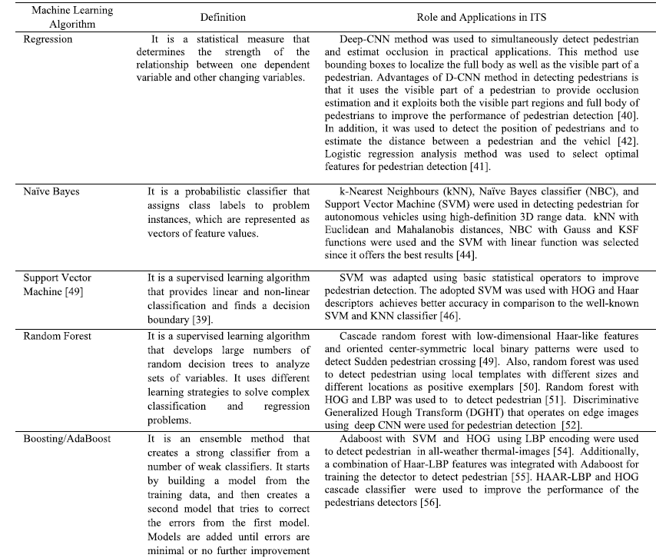

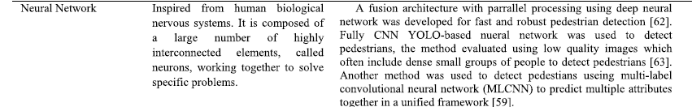

**VIII-Case study : Traffic Prediction using GRU :**

1-GRU :

Introduced by **Cho, et al.** in 2014, GRU (Gated Recurrent Unit) aims to solve the vanishing gradient problem which comes with a standard recurrent neural network. GRU can also be considered as a variation on the LSTM because both are designed similarly and, in some cases, produce equally excellent results.

to solve the vanishing gradient problem of a standard RNN, GRU uses, so-called, update gate and reset gate. Basically, these are two vectors which decide what information should be passed to the output. The special thing about them is that they can be trained to keep information from long ago, without washing it through time or remove information which is irrelevant to the prediction.

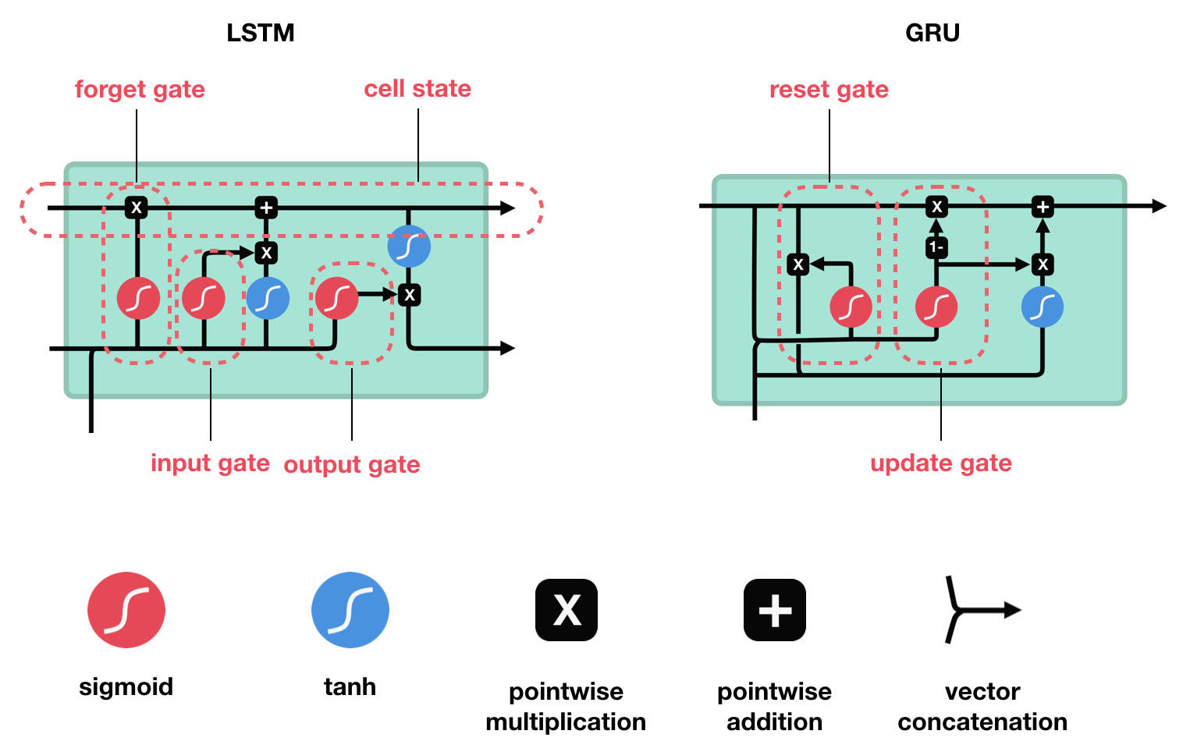

**2-used technologies :**

Language :





Keras



TensorFlow

Importing libraries :

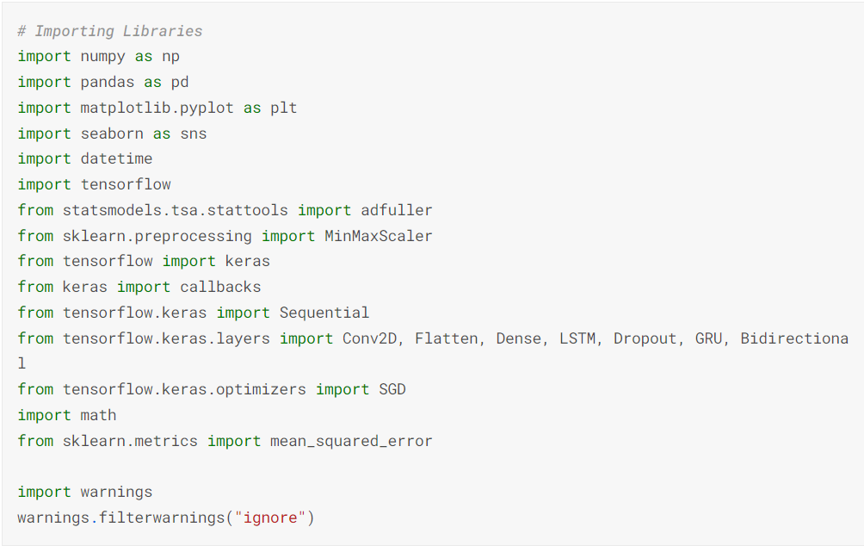

Loading Data :

Dataset imported from Kaggle

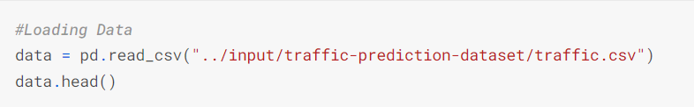

Exploring data :

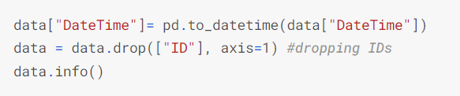

Output:

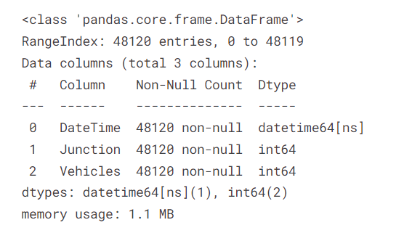

Data visualization :

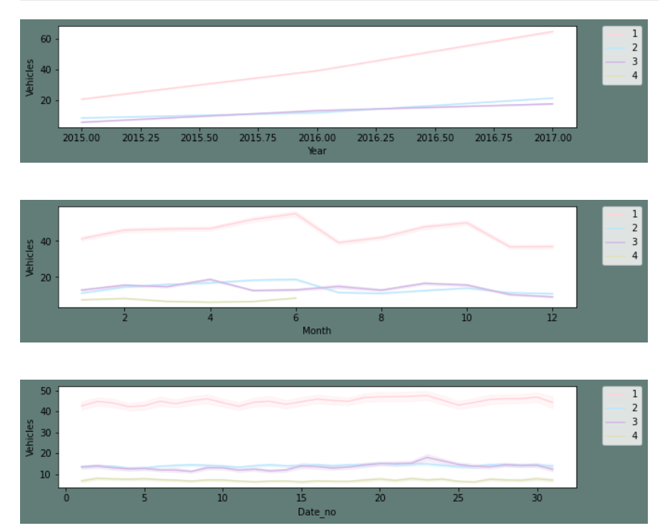

**From the above plot following things can be concluded:**

Yearly, there has been an upward trend for all junctions except for the fourth junction. As we already established above that the fourth junction has limited data and that don't span over a year.

We can see that there is an influx in the first and second junctions around June. I presume this may be due to summer break and activities around the same.

Monthly, throughout all the dates there is a good consistency in data.

For a day, we can see that are peaks during morning and evening times and a decline during night hours. This is as per expectation.

For weekly patterns, Sundays enjoy smoother traffic as there are lesser vehicles on roads. Whereas Monday to Friday the traffic is steady.

**-Model building :**

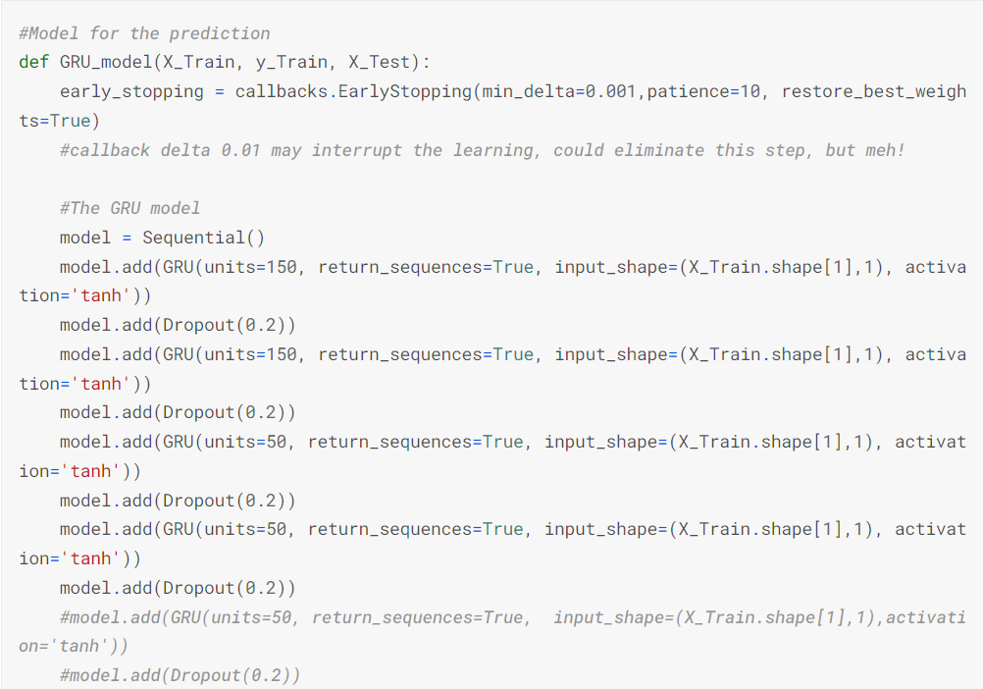

Fitting the model:

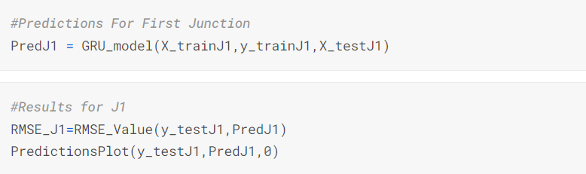

Results :

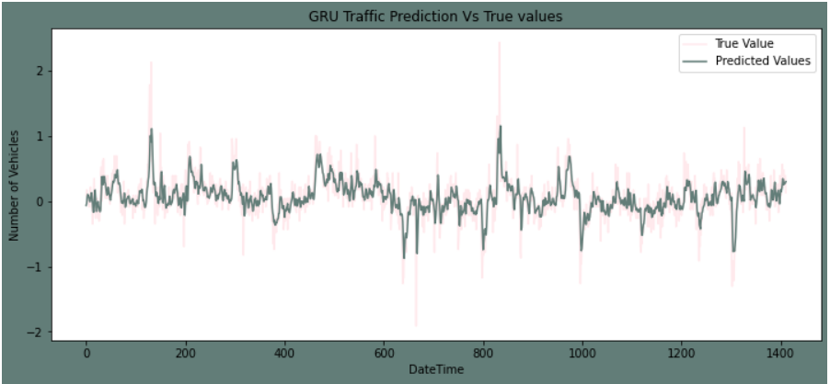

Junction 1 true values vs predicted ones

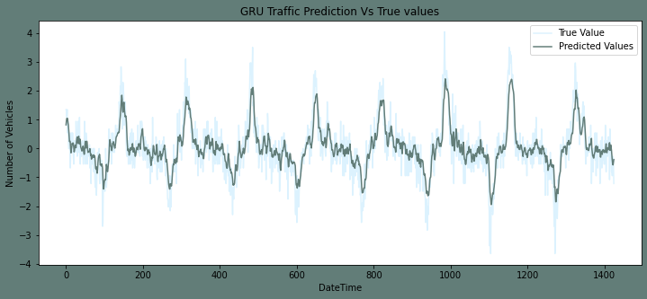

Junction 2 true values vs predicted ones

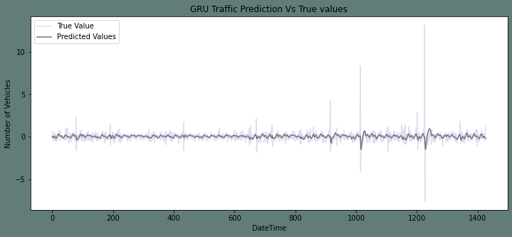

Junction 3 true values vs predicted ones

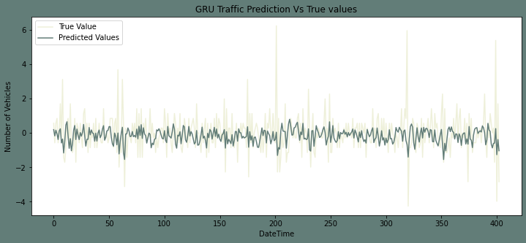

Junction 4 true values vs predicted ones

***Summary:***

The Number of vehicles in Junction one is rising more rapidly compared to junction two and three. The sparsity of data in junction four bars us from making any conclusion on the same.

The Junction one's traffic has a stronger weekly seasonality as well as hourly seasonality. Whereas other junctions are significantly linear.

**Conclusion:**

Intelligent transportation systems are a new type of transport management system that is gradually being replaced by automated control systems. They are focused on modeling various cases and forecasting of dangerous situations and be used as a decision-making tool in the condition of great complexity and large amounts of data.